**ANALYSING THE SHARE PRICE OF RELIANCE INDUSTRIES**

(4 min read)

Data visualization refers to the presentation of data in a graphical or pictorial form. It enables viewers and users to understand small or big data easily and identify key patterns and gain insights. It helps in removing noise from complicated data sets and highlights the information in a meaningful way. We need data visualisation because looking at a visual summary of information rather than thousands of rows on a spreadsheet makes it easier to spot patterns and trends. Since the goal of data analysis is to gain insights, data that is visualised is far more valuable Even if a data analyst extracts insights from data without using visualization, communicating the meaning will be very difficult. Charts and graphs make communicating data findings easier even if you can identify the patterns without them.

In this article, candlestick charts which are used by traders to determine possible price movement based on past patterns are depicted. It is composed of three parts: the upper shadow, lower shadow, and body. The body is coloured green or red. Each candlestick represents a segmented period. There are four data points in every candlestick: the open, high, low, and close. The open and close is the first and last trade, high and low is the highest and the lowest trade of the period. When the bar is green and high compared to other periods of time, it suggests that buyers are quite bullish (investors believe the stock is going up) and a red bar, buyers become bearish (investors believe the stock is going down).

**Figure 1**

*Candlestick Basics*

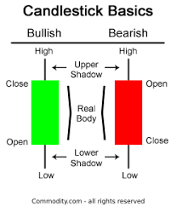

Note. [1]

**Why does the stock price (CMP) fluctuate?**

If everyone wants to buy shares of the same company, there will be a  
shortage of shares, leading to the shooting up of the stock price of the company. And the opposite happens if there are too many people who want to sell their shares, but no one wants to buy them. There can be several reasons for buying and selling of shares of a particular company such as product launches, increase/decrease of revenue, increased/reduced debt, changes in the management of the company, any mergers, and acquisitions. Investor sentiment, Interest rates, Politics, Current events, natural calamities, exchange rates etc.

Now that we know what data visualisation and candlestick charts are, let us talk about Reliance Industry. The name itself brings a lot of chimes for us in India. Hence, we pondered investigating the business during the most recent half a year and illuminating the speculations that helped him in turning into the symbol he is today.

The factors are mentioned below:

1. **Investments:**

While global economies were under crisis due to the coronavirus pandemic it has been no secret that Mr Mukesh Ambani's aim was to muster enough cash to make RIL net debt-free by 2021. He has gone to extreme lengths to ensure this by wooing investors from all over the world. Reliance Industries' (RIL) fundraising blitz in recent months has brought in ₹1.9-lakh-crore by stripping almost 33 per cent stake in Jio Platforms to a varied blend of **14 investors**, depicted in the infographic.

**Figure 2**

*Reliance Industry Deals*

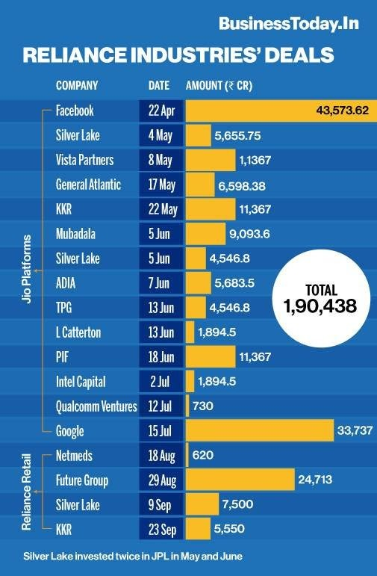

Note. [2]

1. **Rights Issue:**   
   Apart from the investments, to meet the lofty promise, the company needs more money. So now they are turning back to existing investors - people who own parts of RIL to step in and help with the debt burden. They went for a Rights Issue, and here is what has happened. The company issued 41 crore new shares at a discount of 14% due to which RIL is expected to raise close to **₹53,125 crores** through this little program and the allotment took place on 15th June. It was the largest non-financial Rights Issue in the past 10 years.
2. **Annual General Meeting:**Now let us talk about the Annual General Meeting (AGM) which happened on 15th July 2020. Mukesh Ambani, the Chairman of Reliance Industries, said in his address to shareholders, "Reliance is now truly a zero net debt company, well ahead of my goal of March 2021. It has an extremely strong Balance Sheet that will support growth plans for its three Hyper-Growth Engines - Jio, Retail and O2C".  
   He also told shareholders that the Saudi Aramco arrangement has not advanced according to the original deadlines due to unexpected circumstances in the energy sector and the COVID-19 scenario.

**Figure 3**

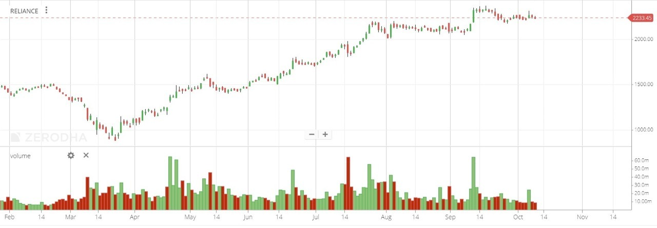

Each of the factors mentioned above has had some effect on the share price of the company. The impact could be positive, as seen from the fourteen investments made in Jio by the various foreign companies and the rights issue. There is also the possibility of such factors having a negative impact. An example of this is the fall-out of the Aramco deal (July 15th, 2020), which caused the share prices of RIL- Jio to plummet by almost 9.14%.

Overall, the large influx of capital has given great belief and confidence to the investors and the market in Jio, which in turn has led to 153% increase in its share prices from its an all-time low of Rs 867.82 on March 23, 2020, to its all-time high of Rs 2,198.7, on July 27, 2020.

To conclude, India's Reliance Jio Platforms is the world's most ambitious tech company. With support from Google, it aims to build an Android-based operating system for Indian needs. The company plans to carry out 5G services in India as soon as spectrum is made available, with the aid of Intel and Qualcomm, who are pioneers in 5G technology. They have also been continuously working on improving and expanding JioMart, it is online grocery delivery service. Thus, seeing the future of Jio, investors feel confident in its success, but let us wait and see what happens.

TEAM 4

1. (Pines, 2021). Candlestick Basics: All the Patterns to Master Before Your Next Trade.  
   <https://commodity.com/technical-analysis/candlestick-basics/>
2. (Sharma, 2020). Reliance Industry Deals. [BusinessToday.in](https://www.businesstoday.in/current/corporate/mukesh-ambani-reliance-industries-signs-18-deals-since-covid-19-outbreak-india/story/416842.html)